Worksheet


Items highlighted in yellow are tasks for you to complete
Items in Blue italics are help tips

Photo Emotions Graphic Design Y9

A collection of at least six photographs that represent emotions – Photographs should be mounted for presentation and stored electronically in the Portfolio

 Sadness

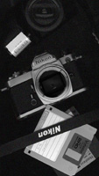 Industry

 Happiness

Need help just ask

